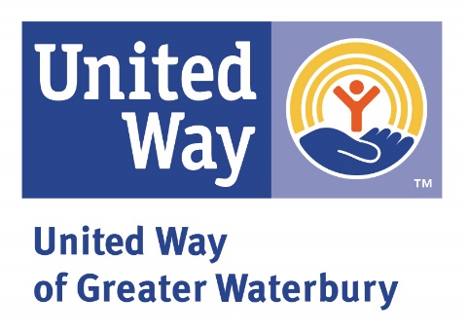**United Way of Greater Waterbury’s Need to Read Suggested Book List**

Thank you for reading a book and adding to our growing library of videos. You are making a huge impact as children enjoy the story you are about to read!

Children from lower income households hear 30 million words before their third birthdays, as compared to their more affluent peers. When children hear your voice, they will also hear those vital words as they learn the joy of reading.

Since your recording will appear on the United Way of Greater Waterbury’s YouTube channel, we must be sure to respect the copyright privileges of the publisher and author as we make these recordings public.

Flashlight Press has agreed to support the United Way’s education strategy by giving permission to record readings of its books. [Click here](http://flashlightpress.com/our-books/) for a full list of titles available from this publisher.

*At the beginning of your video, please state the title of the book, the names of both the author and illustrator, and that you are reading the book, “With permission from Flashlight Press.”*

These books are available from Amazon and Barnes and Noble. Many are also available from your local library! United Way is proud to support the Connecticut Library Association’s Passport to Connecticut Libraries Program and invites you to visit the public library in your hometown to obtain your passport.

When you visit any one of the 143 Connecticut public libraries participating in this program during the month of April, you can get your passport stamped and receive a small gift. This is a fun activity for individuals and families. It’s also a great time to pick up one of the books from Flashlight Press and start your reading experience with the United Way Community!

**But wait! There’s more!**

In addition to books from Flashlight Press, the United Way of Greater Waterbury is highlighting the work of local authors. Woodbury resident and author David Newell released his first children’s book, “Petey and Quackers,” in December of 2021. This true story recounts the tale of a pigeon befriended by a duck and is a heartwarming tale of how friendship can flourish despite differences. This book is available on Amazon, at Barnes and Noble, and at the Woodbury and Bethlehem Public Libraries.

***Tip: Through the Connecticard system, libraries in our state share books. Ask your local librarian to help you find the books you want to read.***